Assignment No: 01

Code:

class Vehicle {

    void start() {

        System.out.println("Vehicle started.");

    }

}

class Car extends Vehicle {

    @Override

    void start() {

        System.out.println("Car started.");

    }

}

class Motorcycle extends Vehicle {

    @Override

    void start() {

        System.out.println("Motorcycle started.");

    }

}

class Garage {

    void serviceVehicle(Vehicle vehicle) {

        vehicle.start(); // Polymorphic call

        System.out.println("Vehicle serviced.\n");

    }

}

public class inherit {

    public static void main(String[] args) {

        Car myCar = new Car();

        Motorcycle myBike = new Motorcycle();

        Garage myGarage = new Garage();

        System.out.println("Servicing the car:");

        myGarage.serviceVehicle(myCar);

        System.out.println("Servicing the motorcycle:");

        myGarage.serviceVehicle(myBike);

    }

}

Output:

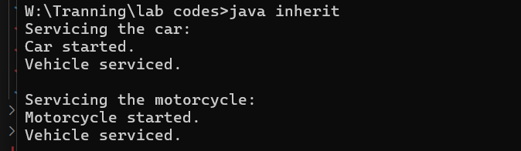

Assignment No: 02

Code:

class Student {

    String name;

    int age;

    String department;

    Student() {

        name = "Unknown";

        age = 20;

        department = "Unassigned";

    }

    Student(String name, int age) {

        this.name = name;

        this.age = age;

        this.department = "IT";

    }

    Student(String name, int age, String department) {

        this.name = name;

        this.age = age;

        this.department = department;

    }

    void displayDetails() {

        System.out.println("Name: " + name);

        System.out.println("Age: " + age);

        System.out.println("Department: " + department);

        System.out.println();

    }

}

public class studmang {

    public static void main(String[] args) {

        Student student1 = new Student();

        Student student2 = new Student("Piyush", 21);

        Student student3 = new Student("Riya", 22, "Computer Engineering");

        System.out.println("Student 1 Details:");

        student1.displayDetails();

        System.out.println("Student 2 Details:");

        student2.displayDetails();

        System.out.println("Student 3 Details:");

        student3.displayDetails();

    }

}

Output:

